Edy Humberto Felix Mascareño
AL0296376
Diseño de aplicaciones web
PROJECT: HALCON

Web application for construction materials distributor

Learning Outcome 1
Analysis and planning of the system

1. GitHub Repository
The first thing I did was create the GitHub repository where all the project code will be stored. Here are the details of the repository:

1.1 Repository Details
Field | Value
Name | halcon-web-app
Visibility | Private
URL | https://github.com/EderZ23/halcon-web-app/tree/main
Description | Web app for order management at Halcon Distributor
README | Yes, included
.gitignore | Configured for Node.js
License | MIT

1.2 Repository Structure
The repository is organized into folders to keep each part of the project separate and easy to find:
Folder / File | What it is for
/frontend | Everything the user sees (pages, buttons, forms, etc.)
/backend | The server and the system logic
/database | SQL scripts to create the database
/docs | Project documents and diagrams
.gitignore | Tells Git which files to ignore
README.md | Explains what the project is about

2. Work Methodology

2.1 Chosen Methodology: SCRUM
For this project I chose the SCRUM methodology. This is a way of working in an organized way where the project is split into small parts called sprints, each one about two weeks long. At the end of each sprint there is something working that can be shown to the client.

2.2 Why I Chose SCRUM
- The client might want to change or add things during the project, and SCRUM makes that easy to handle.
- The system has clearly separated parts (orders, users, photos) that can be built one at a time.
- Progress can be shown to the client little by little, without waiting for everything to be done.
- If something goes wrong, it gets noticed quickly because there are constant reviews.
- It is the most widely used methodology for building web applications today.

2.3 Team Roles
Role | What they do
Product Owner | Represents the client. Decides which features are most important to build first.
Scrum Master | Makes sure the team can work well and helps solve any problems that come up.
Development Team | The people who design, code, and test the application.

2.4 Sprint Plan
Sprint | Duration | What will be done
Sprint 0 | 1 week | Analyze the system, design the database, and create the diagrams
Sprint 1 | 2 weeks | Build the login, users, and roles modules
Sprint 2 | 2 weeks | Create, list, and change the status of orders
Sprint 3 | 2 weeks | Upload photos and let customers check their order status
Sprint 4 | 1 week | Deleted orders, restore feature, and final testing

3. System Diagrams

3.1 BPMN Diagram – Order Life Cycle
This diagram shows the full process an order goes through, from the moment the customer calls the company until the materials are delivered. Each row (swim lane) represents a different department and shows what each one has to do.

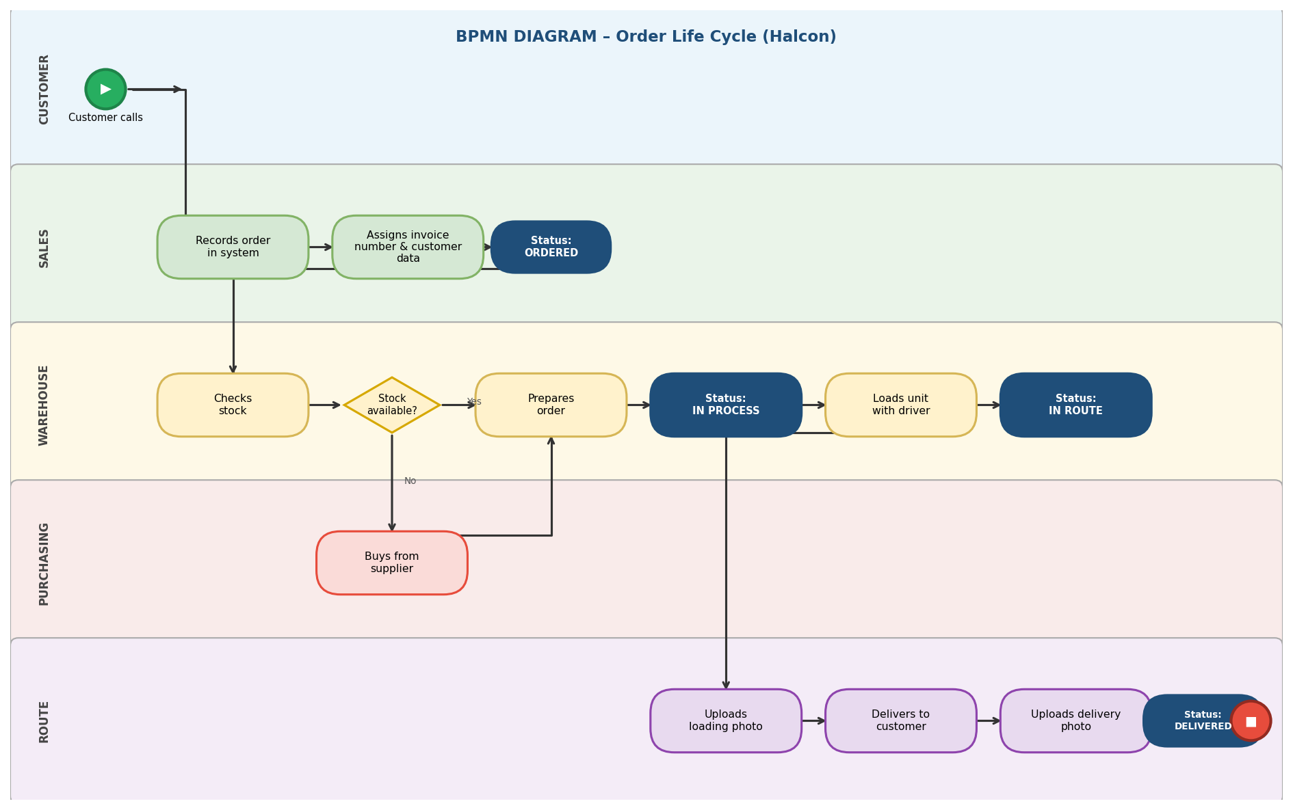

3.2 Class Diagram
This diagram shows the main parts of the system as blocks: User, Role, Order, OrderStatus, and OrderPhoto. Each block has its data (attributes) and the actions it can perform (methods). The lines show how they are connected to each other.

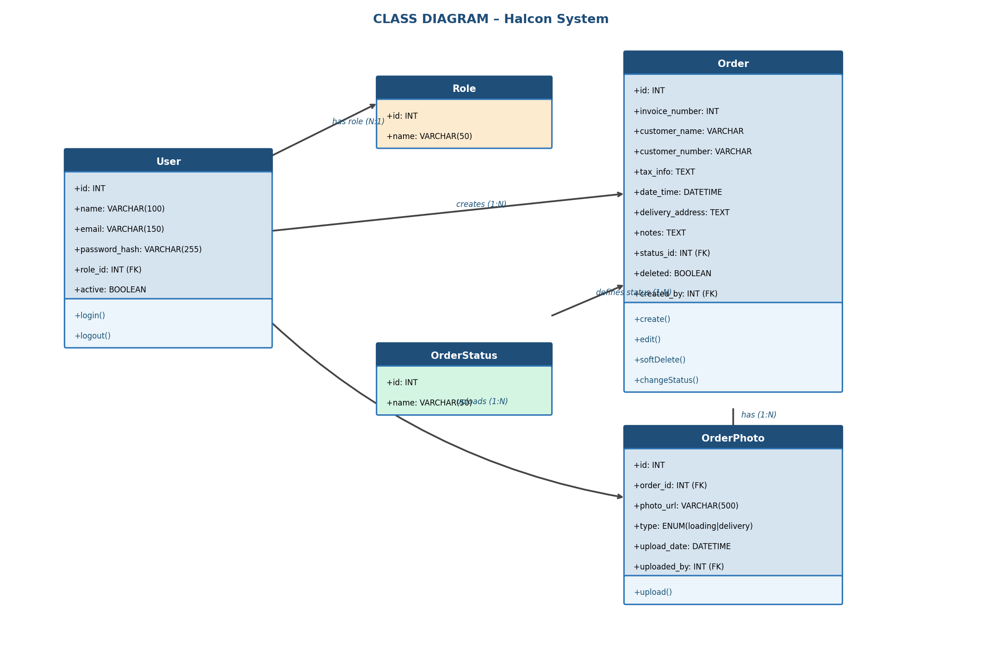

3.3 Activity Diagram
This diagram works like a map of the steps followed during an order process. It shows who does what at each point, including the decision of whether there is stock in the warehouse or not, and the status changes at each stage.

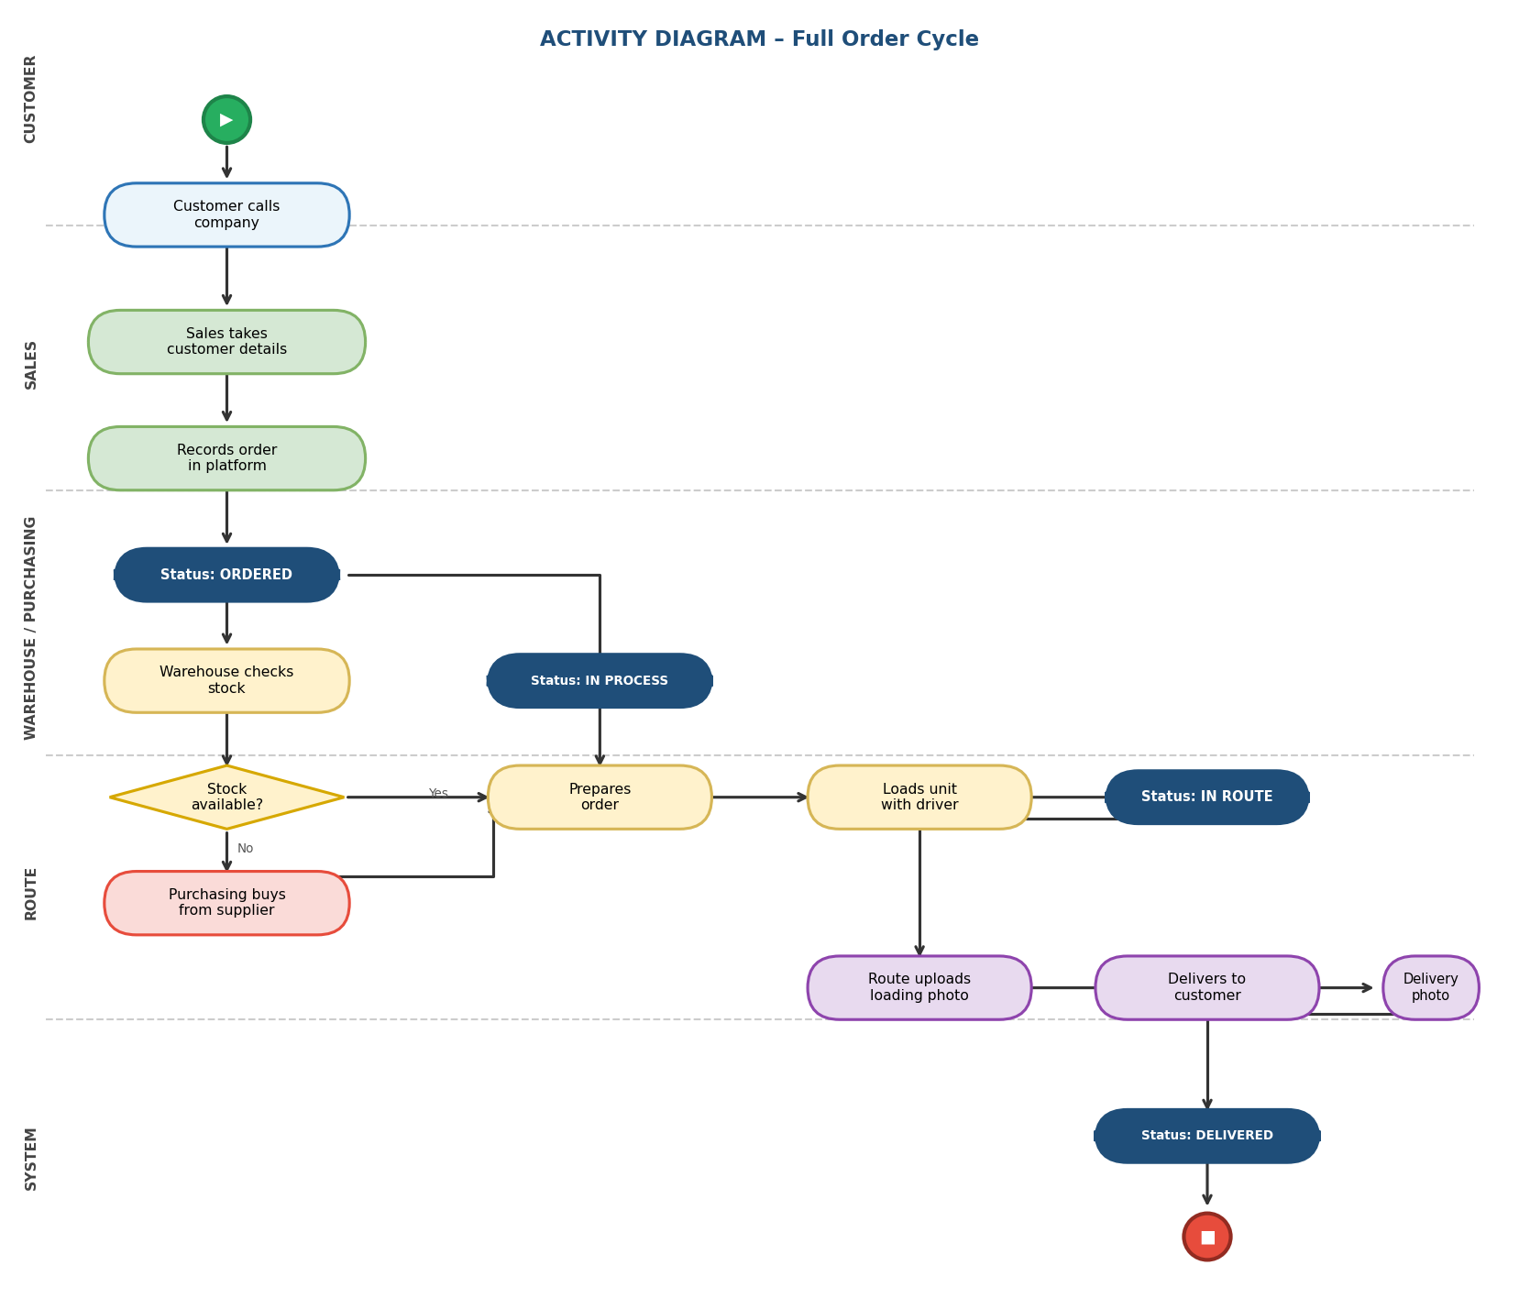

3.4 Use Case Diagram
This diagram shows what each type of person can do inside the system. For example, the customer can only check their order, while someone from the Route department can upload photos. The stick figures represent the actors and the ovals represent the system actions.

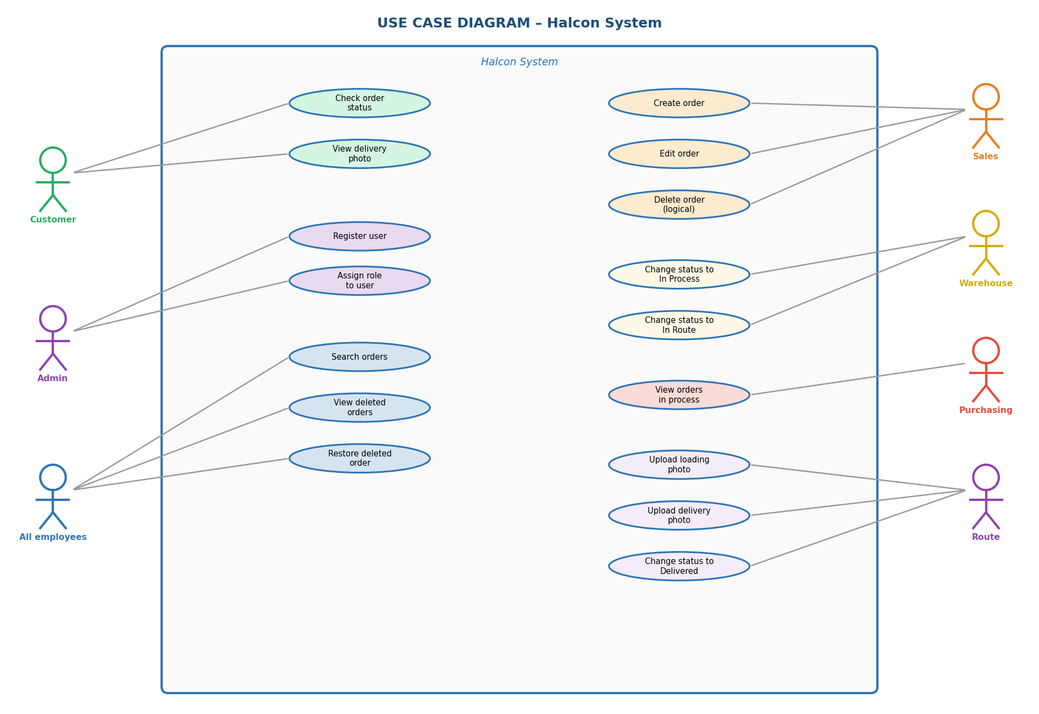

4. Database and ER Diagram

4.1 Chosen Database: MySQL
I chose MySQL because it stores information in tables that are related to each other, which is perfect for this system. It is also free, very well known, and easy to use with tools like MySQL Workbench. It works well with the programming languages that will be used in this project.

4.2 System Tables

Table: roles
Field | Type | Constraint | What it is for
id | INT | PK, AUTO_INCREMENT | Unique number for each role
nombre | VARCHAR(50) | NOT NULL, UNIQUE | Role name: Admin, Sales, Purchasing, Warehouse, Route

Table: users
Field | Type | Constraint | What it is for
id | INT | PK, AUTO_INCREMENT | Unique number for each user
nombre | VARCHAR(100) | NOT NULL | Full name of the employee
email | VARCHAR(150) | NOT NULL, UNIQUE | Email used to log in
password_hash | VARCHAR(255) | NOT NULL | Password stored securely
rol_id | INT | FK → roles(id) | Which role the user has
activo | TINYINT(1) | DEFAULT 1 | Whether they are active (1) or not (0)
creado_en | DATETIME | DEFAULT NOW() | When they were registered

Table: order_status
Field | Type | Constraint | What it is for
id | INT | PK, AUTO_INCREMENT | Unique number
nombre | VARCHAR(50) | NOT NULL, UNIQUE | Ordered / In Process / In Route / Delivered

Table: orders
Field | Type | Constraint | What it is for
id | INT | PK, AUTO_INCREMENT | Unique number for each order
numero_factura | INT | NOT NULL, UNIQUE | Consecutive invoice number
nombre_cliente | VARCHAR(150) | NOT NULL | Customer name or company name
numero_cliente | VARCHAR(50) | NOT NULL | Unique number assigned to the customer
datos_fiscales | TEXT | NULL | Tax ID, billing address, etc.
fecha_hora | DATETIME | DEFAULT NOW() | When the order was placed
direccion_entrega | TEXT | NOT NULL | Where the order will be delivered
notas | TEXT | NULL | Extra comments or notes
status_id | INT | FK → order_status(id) | What status the order is in
eliminado | TINYINT(1) | DEFAULT 0 | 0=active, 1=deleted (still in the database)
creado_por | INT | FK → users(id) | Who created the order
modificado_en | DATETIME | NULL | When it was last modified

Table: order_photos
Field | Type | Constraint | What it is for
id | INT | PK, AUTO_INCREMENT | Unique number for each photo
pedido_id | INT | FK → orders(id) | Which order the photo belongs to
url_foto | VARCHAR(500) | NOT NULL | Where the image is saved
tipo | ENUM('carga','entrega') | NOT NULL | Whether it is a loading or delivery photo
fecha_subida | DATETIME | DEFAULT NOW() | When it was uploaded
subida_por | INT | FK → users(id) | Which Route employee uploaded it

4.3 How the Tables are Related
Table | Related to | Type | Explanation
roles | users | 1 to many | One role can have many users
users | orders | 1 to many | One user can create many orders
order_status | orders | 1 to many | One status can be assigned to many orders
orders | order_photos | 1 to many | One order can have several photos
users | order_photos | 1 to many | One user can upload several photos

5. Personal Reflection

The thing that caught my attention the most was the permissions system. It is not enough to just have departments — the system must make sure each person can only do what they are supposed to do. For example, only people from the Route department can upload photos, and that has to be enforced from the server side, not just on the screen.

I also realized how important it is to design the database tables well from the start. If something is missing or done wrong, it becomes a real problem to fix later when the system is already running. That is why I spent time thinking through each table before writing any code.

Choosing SCRUM feels like the right call because in real life clients always change their mind or ask for new things. With this method we can adjust the project without losing everything that was already done.

Finally, I learned that doing a good analysis at the beginning, even though it feels like time where no code is written, helps a lot later on. With clear diagrams and a well-defined database, the development process will be much more organized and easier to follow.

